Lab 9:

Running in terminal:

Running in Minikube URL:

Reddit Service Endpoint:

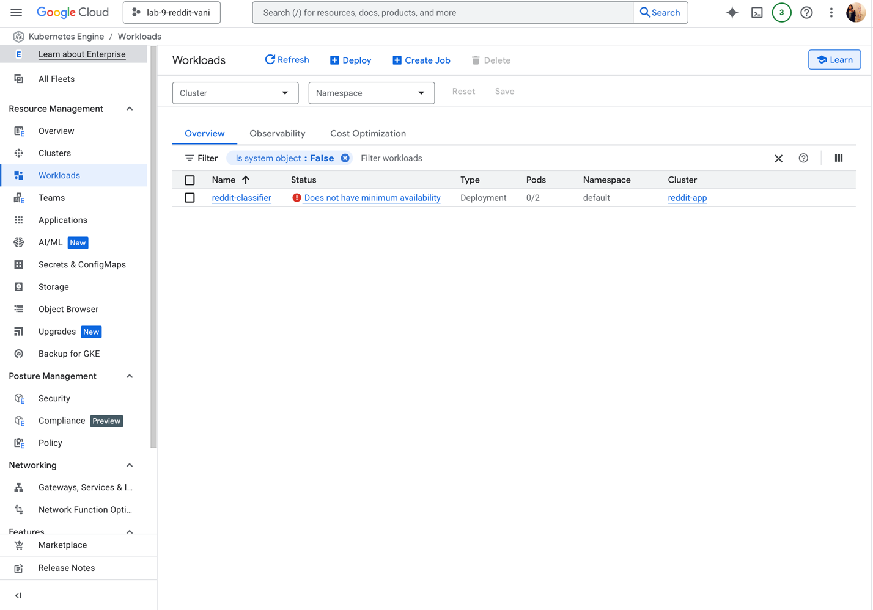

Actual app running:

